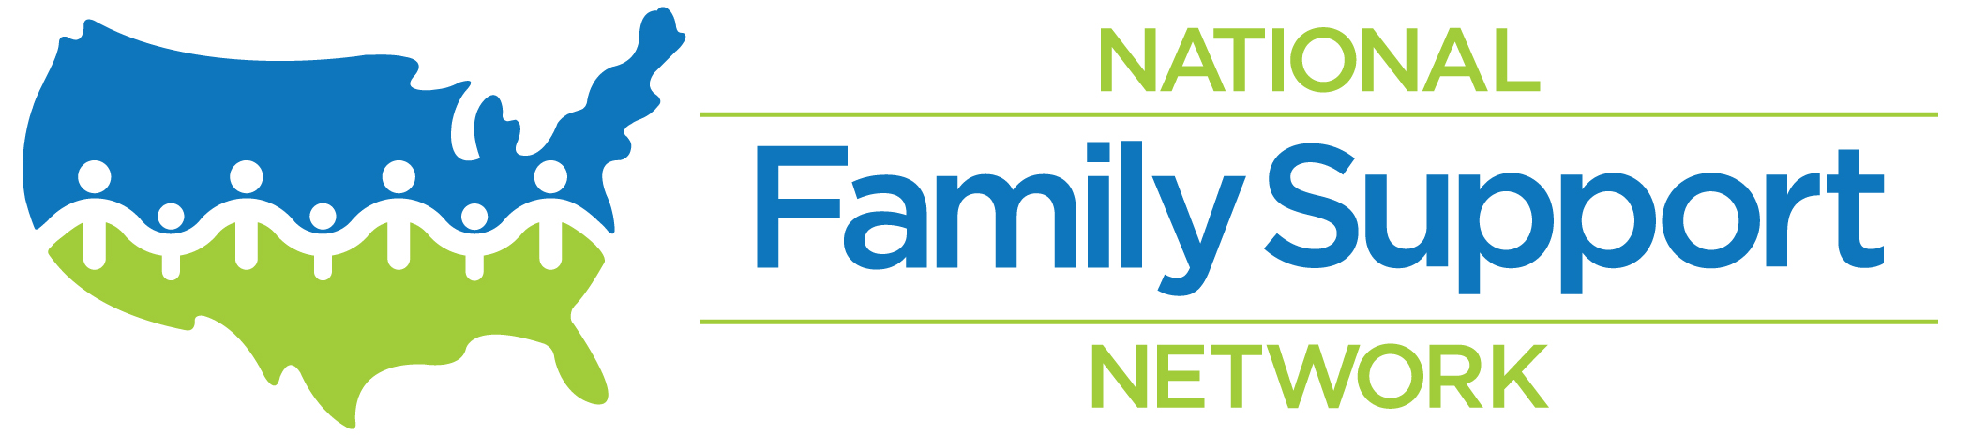
2019-2020 Membership Agreement

As a Network of two or more Family Resource Centers/Family Strengthening organizations in the state of ____________, [Network name] __________________________________________________________________ agrees to support the National Family Support Network (NFSN) and its mission as Member. There are currently _________ [Please write a number] centers/organizations/members in the Network.

Membership Responsibilities
- Abide by the Family Support Principles and promote the Strengthening Families Protective Factors
- Support the implementation of the Standards of Quality for Family Strengthening & Support
- Work together with all members with mutual respect and cooperation
- Share relevant information, resources, and expertise with other members
- Participate in regular monthly member meetings (2nd Monday of each month, 12-1:30pmET)
- Participate in annual in-person Member Convening and NFSN Forum
- Contribute perspective and expertise on NFSN Committees as available
- Ensure that the NFSN has current contact information for Network representatives on an ongoing basis

Membership Renewal
- $500 - Volunteer-coordinated Network (coordinated solely by Family Support Program staff serving in volunteer roles)
- $750 - All other Networks (non-profit, government-coordinated, foundation-coordinated, consultant coordinated, etc.)

First-time Membership Dues
- $250 - Volunteer-coordinated Network
- $375 - Non-volunteer coordinated Network

____________________________________________________________________________________
Name Date

____________________________________________________________________________________
Network Name Network Position

____________________________________________________________________________________
Address

(_________)____________________________ (__________)______________________________
Phone Number Phone Number #2

_______________________________________ ________________________________________
Email Address Network Website

Membership dues are valid through June 30, 2020. Please make a copy of this document for your records and send the original with a check made payable to “WRAG-NFSN” and send to: Julie Matusick, Membership & Administration Manager, National Family Support Network, 11397 Hendy Hollow Road, Corning, NY 14830. If you have any questions, please contact Julie Matusick at julie@nationalfamilysupportNetwork.org or (607) 738-7429.

